**// Subroutine : UpdateButtonClick_CUSOMTIZE_BUTTON()**

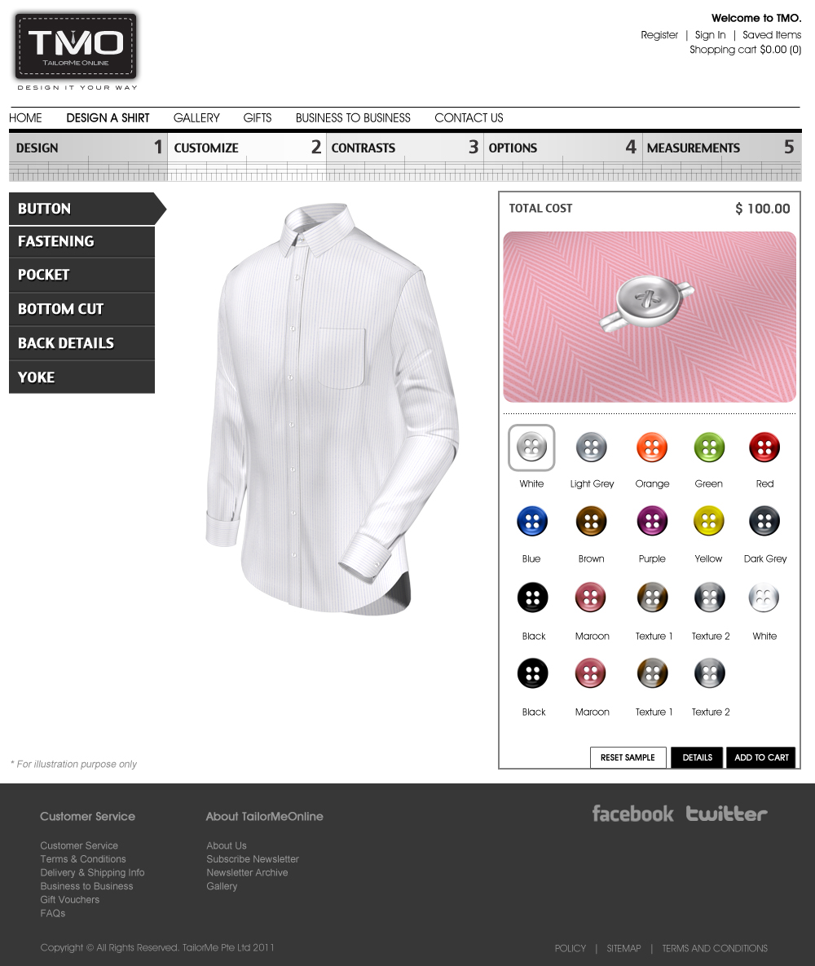

// Siva, note that the above button icons are outdated. Jean Nie should have given you an updated set. If not let me know.

Upon clicking the any button icon:

// Note : Number the button icon in running number from 0001 onwards (ie. 0001, 0002, … , 0017)

ButtonLyr03[4] = ConvertToString(Button Number);

PlacketLyr04[4] = ConvertToString(Button Number);

PlacketContrastLyr06[4] = ConvertToString(Button Number);

TieFixLyr05[4] = ConvertToString(Button Number);

CollarLyr07[4] = ConvertToString(Button Number);

CollarLyr09[4] = ConvertToString(Button Number);

CuffLyr05[4] = ConvertToString(Button Number);

ShirtLyr07[4] = ConvertToString(Button Number);

ShirtLyr11[4] = ConvertToString(Button Number);

ShirtLyr15[4] = ConvertToString(Button Number);

Call Subroutine : RefreshFilenames();

Call Subroutine : DisplayButton(); // This updates the button window

Call Subroutine : DisplayFullview(); // This updates the full shirt window

**// End of Subroutine : UpdateButtonClick_CUSTOMIZE_BUTTON()**